Examen 4
1. Question
View and examine the structure of the PROGRAMS table.
Table: PROGRAMS
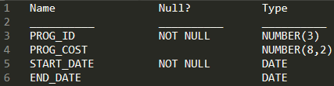
Identify two SQL statements which would execute successfully. (Choose two)
- SELECT NVL(MONTHS_BETWEEN(start_date - end_date),'Ongoing') FROM programs;
- SELECT NVL(TO_CHAR(MONTHS_BETWEEN(start_date,end_date)),'Ongoing') FROM programs;
- SELECT NVL(ADD_MONTHS(END_DATE,1)SYSDATE) FROM programs;
- SELECT TO_DATE(NVL(END_DATE,SYSDATE)) FROM programs;
Correctas: B,D
2. Question
View and examine the following data listing for a table STUDENTS:.
Table: STUDENTS
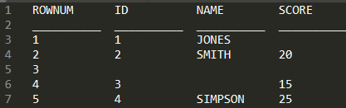
Given:
• ROWNUM is a pseudocolumn.
• Row 3 is completely NULL.
• The SCORE for JONES is NULL.
Examine the following SELECT statement.
Exhibit 1:
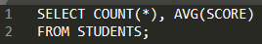
Identify the result of the query execution.
- 3,20
- 3,15
- 5,20
- 2,12.5
- 4,15
- The query would return an error.
Correcta: C
3. Question
View and examine the data in the EMPLOYEES table.
Table: EMPLOYEES
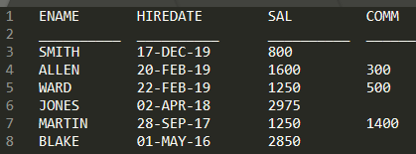
Required: Generate a report showing the total salary paid to each employee to date.
Identify the best SQL query which would give you the required output.
- SELECT ename | | 'joined on' | | hiredate || ', the total salary paid is ' | | TO_CHAR (ROUND(ROUND(SYSDATE - hiredate) / 365 * sal + comm)) "SALARY TO DATE" FROM employees;
- SELECT ename | | ' joined on ' | | hiredate ', the total salary paid is ' TO_CHAR ROUND((ROUND(SYSDATE) - TRUNC(hiredate)) / 365 * sal) "SALARY TO DATE" FROM employees;
- SELECT ename | | 'joined on' | | hiredate | | ', the total salary paid is ' TO_CHAR (ROUND(SYSDATE - hiredate) / 365 * sal + comm) "SALARY TO DATE" FROM employees;
- SELECT ename | | ' joined on ' | | hiredate | | ', the total salary paid is ' || TO_CHAR(ROUND(TRUNC(SYSDATE - hiredate) / 365 * sal)) "SALARY TO DATE" FROM employees;
Correcta: D
4. Question
View and examine the following SQL exhibit.
Exhibit: 1
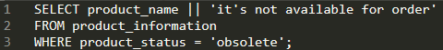
Given: The following error has been generated by executing the above query.
Exhibit: 2
Identify the action needed execute the query successfully.
- Use the Oracle (q) operator and delimiter to allow the use of a single quotation mark within the literal character string in the SELECT clause
- Use the escape character to negate the single quotation mark within the literal character string in the SELECT clause
- Enclose the character literal string in the SELECT clause within double quotation marks
- Remove the single quotation marks enclosing the character literal string in the SELECT clause
Correcta: A

5. Question
- The file is in the current directory where is running.employees.datsqlldr
- SQL*Loader was invoked to load data into the table in the HR schema.EMPLOYEES
Identify two true statements regarding the command. (Choose two)
- It fails because no SQL *Loader data file location is specified.
- It fails if the HR user does not have the CREATE ANY DIRECTORY privilege.
- It succeeds with default settings if the EMPLOYEES table belonging to HR is already defined in the database.
- It fails because no SQL *Loader control file location is specified.
Correctas: C,D
6. Question
Identify two true statements about views. (Choose two)
- VIEW can be updated without the need to re-grant privileges on the VIEW.
- VIEW can be indexed.
- The with CHECK clause prevents certain rows from being updated or inserted in the underlying table through the VIEW.
- The with CHECK clause prevents certain rows from being displayed when querying the VIEW.
- Tables in the defining query of a VIEW must always exist in order to create the VIEW.
Correctas: C,E
7. Question
View and examine the structure of CUSTOMERS table.
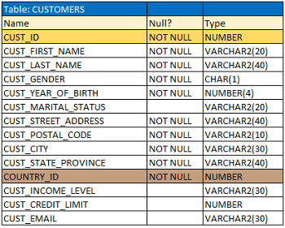
Required:
• Using the CUSTOMERS table, generate a report that shows an increase in the credit limit by 15% for all customers.
• Customers whose credit limit has not been entered should have the message “N/A” displayed.
Identify the SQL query which would give you the required output.
- SELECT cust_id,cust_last_name,cust_city,cust_credit_limit "CURRENT CREDIT", NVL(cust_credit_limit * 1.15),'N/A' "NEW CREDIT" FROM customers;
- SELECT cust_id,cust_last_name,cust_city,cust_credit_limit "CURRENT CREDIT", NVL(TO_CHAR(cust_credit_limit * 1.15),'N/A') "NEW CREDIT" FROM customers;
- SELECT cust_id,cust_last_name,cust_city,cust_credit_limit "CURRENT CREDIT", NVL(cust_credit_limit * .15),'N/A' "NEW CREDIT" FROM customers;
- SELECT cust_id,cust_last_name,cust_city,cust_credit_limit "CURRENT CREDIT", TO_CHAR(NVL(cust_credit_limit * 1.15),'N/A') "NEW CREDIT" FROM customers;
- SELECT cust_id,cust_last_name,cust_city,cust_credit_limit "CURRENT CREDIT", NVL(TO_CHAR(cust_credit_limit * .15),'N/A') "NEW CREDIT" FROM customers;
Correcta: C
8. Question
View and examine the structure of ORDERS and ORDER_ITEMS tables.
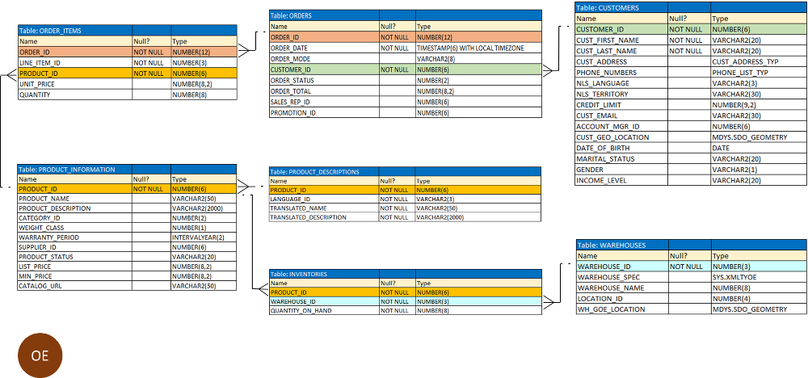
Given: ORDER_ID is the primary key in the ORDERS table and the foreign key of the ORDER_ITEMS table, whose constraint is defined with the ON DELETE CASCADE option.
Identify the DELETE statement which would execute successfully.
- DELETE orders.o, order_items.i WHERE o.order_id = i.order_id;
- DELETE order_id FROM orders WHERE order_total < 1000;
- DELETE orders WHERE order_total < 1000;
- DELETE FROM orders WHERE (SELECT order_id FROM order_items);
Correcta:C
9. Question
View and examine the command to create the BOOKS table.
Exhibit 1:
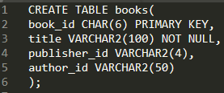
Given: The BOOK_ID value 101 does not exist in the table.
The following SQL statement has now been executed.
Exhibit 2:
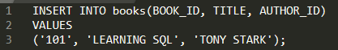
Identify the result of the query execution.
- It executes successfully only if the PUBLISHER_ID column name is added to the columns list and NULL is explicitly specified in the INSERT statement.
- It executes successfully only if NULL is explicitly specified in the INSERT statement.
- It executes successfully only if the PUBLISHER_ID column name is added to the columns list in the INSERT statement.
- It executes successfully and the row is inserted with a blank entry PUBLISHER_ID field.
Correcta: D
10. Question
Identify three actions you can perform only with system privileges. (Choose three)
- Query any table in a database.
- Truncate a table in another schema.
- Log in to a database.
- Execute a procedure in another schema.
- Access flat files via a database, which are stored in an operating system directory.
- Use the WITH GRANT OPTION clause.
Correctas: B,E,F
11. Question
View and examine the structures of the EMPLOYEES and DEPARTMENTS tables.
Table: EMPLOYEES
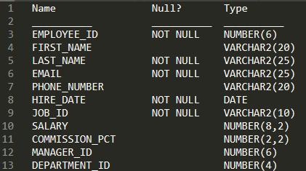
Table: DEPARTMENTS
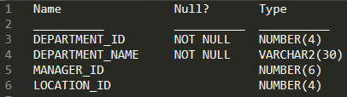
Required: Update EMPLOYEES table as follows:
• Update only those employees who work in Toronto or Seattle (locations 2900 and 2700).
• Set department_id for these employees to the department_id corresponding to London (location_id 2100).
• Set the employees’ salary in location_id 2100 to 1.1 times the average salary of their department.
• Set the employees’ commission in location_id 2100 to 1.5 times the average commission of their department.
The following command has been executed.
Exhibit 1:
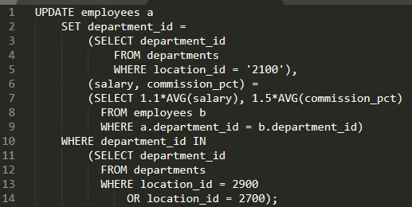
Identify the result of the query execution.
- It generates an error because a subquery cannot have a join condition in a UPDATE statement.
- It executes successfully and gives the desired update.
- It executes successfully but does not give the desired update.
- It generates an error because multiple columns (SALARY, COMMISSION) cannot be specified together in an UPDATE statement.
Correcta: A

12. Question
View and examine the commands used to create DEPARTMENT_DETAILS and COURSE_DETAILS.
Exhibit 1:
Exhibit 2:
Required: Generate a report that shows all course IDs irrespective of whether they have corresponding department IDs or not but no department IDs if they do not have any courses.
Identify the SQL query which would give you the required output.
- SELECT c.course_id, d.department_id FROM course_details c RIGHT OUTER JOIN .department_details d ON (c.depatrment_id=d.department_id)
- SELECT course_id, department_id FROM department_details d RIGHT OUTER JOIN course_details c USING (department_id)
- SELECT c.course_id, d.department_id FROM course_details c FULL OUTER JOIN department_details d ON (c.department_id<>d. department_id)
- SELECT c.course_id, d.department_id FROM course_details c FULL OUTER JOIN department_details d ON (c.department_id=d. department_id)
Correcta: B

13. Question
View and examine the description of the ORDERS table.
Identify two WHERE clause conditions which demonstrate the correct usage of conversion functions. (Choose two)
- WHERE order_date_IN ( TO_DATE('OCT 21 2019','MON DD YYYY'), TO_CHAR('NOV 21 2019','MON DD YYYY') )
- WHERE TO_CHAR(order_date,'MON DD YYYY') = 'JAN 01 2019'
- WHERE order_date > TO_CHAR(ADD_MONTHS(SYSDATE,6),'MON DD YYYY')
- WHERE order_date > TO_DATE('JUL 10 2019','MON DD YYYY')
Correctas: B,D

14. Question
View and examine the following available responses.
Identify the true statement regarding the INTERSECT operator.
- The names of columns in all SELECT statements must be identical.
- It ignores NULLs.
- Reversing the order of the intersected tables alters the result.
- The number of columns and data types must be identical for all SELECT statements in the query.
Correcta: D

15. Question
View and examine the structure of the EMPLOYEES1 table.
Table: EMPLOYEES1
Required: Display the customer names that have the letter ‘a’ in their first name and the letter ‘o’ at the fourth position in their last name only.
Identify the SQL query which would give you the required output.
- SELECT first_name, last_name FROM employees1 WHERE first_name LIKE '%a%' AND last_name LIKE '%o%';
- SELECT first_name, last_name FROM employees1 WHERE LIKE first_name 'a%' AND LIKE last_name '%o';
- SELECT first_name, last_name FROM employees1 WHERE INSTR(first_name,'a') AND SUBSTR(last_name,4,1) = 'o';
- SELECT first_name, last_name FROM employees1 WHERE INSTR(first_name,'a') <> 0 AND SUBSTR(last_name,4,1) = 'o';
Correcta: D

16. Question
View and examine the structure of the PRODUCTS table.
Identify two tasks which would require subqueries. (Choose two)
- Render the total number of products supplied by supplier 102 and have product status as 'OBSOLETE'
- Generate a list of suppliers where the PROD_LIST_PRICE is less than 1000.
- Show the lowest PROD_LIST_PRICE for each product status.
- Show the number of products whose PROD_LIST_PRICE is higher than the average PROD_LIST_PRICE.
- Generate a list of all products where the PROD_MIN_PRICE is higher than the average PROD_LIST_PRICE of all products, and has an orderable status.
Correctas: D,E

17. Question
View and examine the following available responses.
Examine this SQL statement.
Exhibit 1:
Identify two true statements regarding the result. (Choose two)
- The subquery is not a correlated subquery.
- All existing rows in the EMPLOYEES table are deleted.
- The subquery is executed before the DELETE statement is executed.
- The subquery is executed for every row in the employees table.
- The DELETE statement executes successfully even if the subquery selects multiple rows
Correctas: D,E

18. Question
View and examine the following available responses.
Given: The BOOKS_TRANSACTIONS table exists in your database.
Exhibit: 1
Identity the result of the query execution.
- Rows are displayed in the order that they are stored in the table only for the three rows with the lowest values in the key column.
- Rows are displayed in the order that they are stored in the table only for the first three rows.
- The execution fails unless the numeral 3 in the ORDER BY clause is replaced by a column name.
- Rows are displayed sorted in ascending order of the values in the third column in the table.
Correcta: D

19. Question
View and examine the following available responses.
Identify two true statements regarding the execution of the correlated subqueries. (Choose two)
- The nested query executes after the outer query returns the row.
- The nested query executes first and then the outer query executes.
- Each row returned by the outer query is evaluated for the results returned by the inner query.
- The outer query executes only once for the result returned by the inner query.
Correctas: A,C

20. Question
Identify the false selection about Oracle ALIASES.
- Oracle ALIASES negatively impact system performance.
- An alias is mandatory in schema bound views.
- It is acceptable to use spaces when you are aliasing a column name.
- If the alias name contains spaces, you must enclose the alias name in quotes.
- Oracle ALIASES can be used to create a temporary name for columns or tables.
Correcta: A

21. Question
View and examine the following available responses.
Required: Display the first names of all customers from the CUSTOMERS table that contain the character ‘e’ and have the character ‘s’ in the second last position.
Identity the SQL query which would give you the required output.
- SELECT cust_first_name FROM customers WHERE INSTR(cust_first_name, 'e') <> ' ' AND SUBSTR(cust_first_name, -2, 1)='s';
- SELECT cust_first_name FROM customers WHERE INSTR(cust_first_name, 'e') <> 0 AND SUBSTR(cust_first_name, LENGTH(cust_first_name), -2)='s';
- SELECT cust_first_name FROM customers WHERE INSTR(cust_first_name, 'e') <> 0 AND SUBSTR(cust_first_name, -2, 1) = 's';
- SELECT cust_first_name FROM customers WHERE INSTR(cust_first_name, 'e') IS NOT NULL AND SUBSTR(cust_first_name, 1, -2) = 's';
Correcta: C

22. Question
View and examine the following available responses.
Which two statements are true about the DUAL table?
- It can be accessed by any user who has the SELECT privilege in any schema.
- It can be accessed only by the SYS user.
- It can display multiple rows but only a single column.
- It consists of a single row and single column of VARCHAR2 data type.
- It can be used to display only constants or pseudo columns.
- It can display multiple rows and columns.
Correctas: A,D

23. Question
View and examine the following available responses.
Identify the true statement about SQL query processing in an Oracle database instance. (Select best answer)
- During optimization, execution plans are formulated based on the statistics gathered by the database instance, and the lowest cost plan is selected for execution.
- During row source generation, rows that satisfy the query are retrieved from the database and stored in memory.
- During execution, the Oracle server may read data from storage if the required data is not already in memory.
- During parsing, a SQL statement containing literals in the WHERE clause that has been executed by any session and which is cached in memory, is always reused for the current execution.
Correcta: C

24. Question
An Oracle database server session has an uncommitted transaction in progress which updated 5000 rows in a table.
Identify three situations where the transaction completes thereby committing the updates. (Choose three)
- When a DBA issues a successful SHUTDOWN TRANSACTIONAL statement and the user then issues a COMMIT.
- When a DBA issues a successful SHUTDOWN IMMEDIATE statement and the user then issues a COMMIT.
- When a CREATE INDEX statement is executed successfully in the same session.
- When a COMMIT statement is issued by the same user from another session in the same database instance.
- A DBA uses the ALTER TABLE statement to change the name of a column.
- When a CREATE TABLE AS SELECT statement is executed unsuccessfully in the same session.
Correctas: A,C,E

25. Question
View and examine the following available responses.
Given: In the PROMOTIONS table, the PROMO_BEGIN_DATE column is DATE data type and the default date format is DD-MON-RR.
Identify two true statements about expressions using PROMO_BEGIN_DATE contained a query.
- PROMO_BEGIN_DATE - SYSDATE will return an error.
- PROMO_BEGIN_DATE - SYSDATE will return a number.
- PROMO_BEGIN_DATE - 5 will return a date.
- TO_DATE(PROMO_BEGIN_DATE * 5) will return a date
- TO_NUMBER(PROMO_BEGIN_DATE) - 5 will return a number.
Correctas: B,C

26. Question
View and examine the structure of the SALES table.
Table: SALES
Identify two true statements about the SALES1 table. (Choose two)
- It has PRIMARY KEY and UNIQUE constraints on the selected columns which had those constraints in the SALES table.
- It will not be created because of the invalid WHERE clause.
- It will have NOT NULL constraints on the selected columns which had those constraints in the SALES table.
- It will not be created because the column-specified names in the SELECT and CREATE TABLE clauses do not match.
- It is created with no rows.
Correctas: C,E

27. Question
View and examine the following available responses.
Identify two true statements regarding the SQL GROUP BY clause. (Choose two)
- Using the WHERE clause before the GROUP BY clause excludes rows before creating groups.
- The GROUP BY clause is mandatory if you are using an aggregating function in the SELECT clause.
- You can use a column alias in the GROUP BY clause.
- If the SELECT clause has an aggregating function, then columns without an aggregating function in the SELECT clause should be included in the GROUP BY clause.
- Using the WHERE clause after the GROUP BY clause excludes rows after creating groups.
Correctas: A,D

28. Question
View and examine the following CREATE SEQUENCE statement and exhibits.
Exhibit: 1
Identity the result of the final query execution.
- 100
- 10
- 1
- An error.
- 200
- 210
Correcta: A

29. Question
View and examine the following available responses.
Required: Display today’s date in words if the format ‘Fourth of May Two Thousand Twenty’.
Identity the SQL query which would give you the required output.
- SELECT TO_CHAR(SYSDATE, 'fmDdthsp "of" Month Yyyyth') FROM dual;
- SELECT TO_CHAR(SYSDATE, 'fmddthsp 'of' month yyyysp') FROM dual;
- SELECT TO_CHAR(SYSDATE, 'fmDdthsp 'of' Month Yyyysp') FROM dual;
- SELECT TO_CHAR(SYSDATE, 'fmddthsp "of" month yyyysp') FROM dual;
- None are correct.
- SELECT TO_CHAR(SYSDATE, 'fmDdth "of" Month Yyyy') FROM dual;
Correcta: E

30. Question
View and examine the structure of the CUSTOMERS table.
Table: CUSTOMERS
Given: CUSTNO is the PRIMARY KEY.
Required: Determine if any customers’ details have been entered more than once using a different CUSTNO, by listing all duplicate names.
Identity the SQL queries which would give you the required output. (Select two)
- Subquery
- SELF JOIN
- RIGHT OUTER JOIN with SELF JOIN
- LEFT OUTER JOIN with SELF JOIN
- FULL OUTER JOIN with SELF JOIN
Correcta: A,B

31. Question
View and examine the following available responses.
Identify three true statements regarding single-row functions. (Choose three)
- Single row character input and returns number or character value. Functions under the category are CONCAT, LENGTH, SUBSTR, INSTR, LPAD, RPAD, TRIM and REPLACE.
- Single row case conversion functions accept character input and returns a character value. Functions under the category are UPPER, LOWER and INITCAP.
- Single row functions can be character functions, numeric functions, date functions, and conversion functions.
- Single row functions can be character functions, numeric functions, date functions, conversion and audit functions.
- Single row numeric operations return numeric values. Functions under the category are SUM, SUBTRACT, ROUND, TRUNC, and MOD.
- Single row date arithmetic operations return date, character or numeric values. Functions under the category are MONTHS_BETWEEN, ADD_MONTHS, NEXT_DAY, LAST_DAY, ROUND, REPLACE and TRUNC.
Correctas: A,B,C

32. Question
View and examine the following available responses.
Identify three true statements about performing Data Manipulation Language (DML) operations on a view in an Oracle Database.
- The most common uses of views are to simplify data retrieval, maintain logical data independence, and implement data security.
- Views help you allow for hiding columns and rows from the underlying tables.
- A view is simply the representation of a SQL statement that is physically stored and is available to all users.
- Underlying table access can be exposed to external applications via views.
- For a user to see a view, the user must have at least read only access to the source tables which populate a view.
- Data from underlying tables can be exposed to external applications via views.
CORRECTAS: A.B.F

33. Question
View and examine PRODUCTS and SALES tables as well as the exhibit.
Given: The following query is intended to to display product name the number of times the product has been sold.
Exhibit: 1
Identity the result of the query execution.
- The statement executes successfully and produces the required output.
- The statement produces an error because the GROUP BY clause cannot be used in a subquery in the FROM clause.
- The statement executes successfully but does not produce the required output.
- The statement produces an error because a subquery in the FROM clause and outer-joins cannot be used together.
- The statement produces an error because QUANTITY_SOLD cannot be displayed in the outer query.
Correcta: A

34. Question
View and examine the following available responses.
Given: The variables used in your query are never undefined in your session. Both columns are numeric and the WHERE condition is text.
Required: Write a query that prompts for two column names and the WHERE condition each time it is executed in a session but only prompts for the table name the first time it is executed. User input is restricted to numbers and letters.
Identity the SQL query which would give you the required output.
- SELECT col1 = '&&col1', col2 = '&&col2' FROM table = '&&table' WHERE '&&condition' = '&&cond';
- SELECT &col1, &col2 FROM '&&table' WHERE &condition;
- SELECT &col1, &col2 FROM table ="&table" WHERE &condition;
- SELECT col1 = &col1, col2 = &col2 FROM table = &&table WHERE condition = &condition;
- SELECT &&col1, &&col2 FROM table = &&table WHERE &&condition = &&cond;
Correctas: D,E

35. Question
View and examine the structure of the EMPLOYEES table.
Table: EMPLOYEES
Identity the valid SQL query.
- SELECT dept_id, SUM(salary) SALARY FROM employees GROUP BY dept_id HAVING SUM(salary) >= 100 ORDER BY SALARY DESC;
- SELECT dept_id, SUM(salary) SALARY FROM employees GROUP BY SUM(salary) >= 100 ORDER BY SALARY DESC;
- SELECT dept_id, join_date, SUM(salary) SALARY FROM employees GROUP BY dept_id HAVING SUM(salary) >= 100 ORDER BY SALARY DESC;
- SELECT dept_id, join_date, SUM(salary) SALARY FROM employees GROUP BY dept_id HAVING SALARY >= 100 ORDER BY SALARY DESC;
- SELECT dept_id, SUM(salary) SALARY FROM employees GROUP BY dept_id ORDER BY SALARY DESC HAVING SUM(salary) >= 100;
Correcta: A

36. Question
View and examine the following SQL exhibit.
Given: The following command has been executed.
Exhibit: 1
DROP TABLE hr.employees;
Indicate three true statements regarding the result. (Choose three)
- Synonyms for HR.EMPLOYEES are dropped.
- Views referencing HR.EMPLOYEES are dropped.
- All constraints defined on HR.EMPLOYEES are dropped.
- Sequences used to populate columns in the HR.EMPLOYEES table are dropped.
- All indexes defined on HR.EMPLOYEES are dropped.
- The HR.EMPLOYEES table may be moved to the recycle bin.
Correctas: C,E,F

37. Question
Identify three true statements about indexes and their administration in an Oracle database. (Choose three)
- A UNIQUE and non-unique index can be created on the same table column.
- A descending index is a type of function-based index.
- An index can be created as part of a CREATE TABLE statement.
- A DROP INDEX statement always prevents updates to the table during the drop operation.
- If a query filters on an indexed column then it will always be used during execution of the query.
- An INVISIBLE index is not maintained when Data Manipulation Language (DML) is performed on its underlying table.
Correctas: A,B,C

38. Question
View and examine the following available responses.
A non-correlated subquery can be defined as __________. (Choose the best answer.)
- A set of sequential queries, all of which must always return a single value.
- A set of one or more sequential queries in which generally the result of the inner query is used as the search value in the outer query.
- A set of sequential queries, all of which must return values from the same table.
- A SELECT statement that can be embedded in a clause of another SELECT statement only.
Correcta: B

39. Question
View and examine the structure of the PROMOTIONS table and the exhibit.
Table: PROMOTIONS
Evaluate the following SQL statement.
Exhibit: 1
Identity the result of the query.
- It shows a COST_REMARK for all the promos in the table.
- It produces an error because a subquery gives an error.
- It produces an error because subqueries cannot be used with the CASE expression.
- It shows COST_REMARK for all the promos in the promo category 'TV'.
Correcta: A

40. Question
View and examine the data in EMP and DEPT tables and the exhibit.
Given:
• DEPTNO is the PRIMARY KEY in the DEPT table.
• EMPNO is the PRIMARY KEY in the EMP table.
• DEPTNO is the FOREIGN KEY referencing the DEPTNO column in the DEPT table.
The following SQL sequence has been executed.
Exhibit: 1
Indicate the statement which is true regarding the result.
- Only the first INSERT statement would succeed because all constraints except the primary key constraint are automatically retrieved after a table is flashed back.
- Both the INSERT statements would fail because the constraints are automatically retrieved when the table is flashed back.
- Only the SECOND INSERT statement would succeed because all the constraints except referential integrity constraints that reference other tables are retrieved automatically after the table is flashed back.
- Both the INSERT statements would succeed because none of the constraints on the table are automatically retrieved when the table is flashed back.
Correcta: C

41. Question
View and examine the details of the PRODUCT_INFORMATION table.
Table: PRODUCT_INFORMATION
Required: Display PRODUCT_NAME from the table where the CATEGORY_ID column has values 12 or 13, and the SUPPLIER_ID column has the value 102088.
Indicate the statement which is true regarding the result.
- It would not execute because the entire WHERE clause is not enclosed within parentheses.
- It would not execute because the same column has been used twice with the AND logical operator.
- It would execute and return the desired result.
- It would execute but would return no rows.
Correcta: D

42. Question
View and examine the following available responses.
Identify two true statements about the rules of precedence for operators. (Choose two)
- The concatenation operator | | is always evaluated before addition and subtraction in an expression.
- NULLS influence the precedence of operators in an expression.
- Arithmetic operators with equal precedence area evaluated from left to right within an expression.
- Multiple parentheses can be used to override the default precedence of operators in an expression.
- The + binary operator is the highest precedence in an expression in a SQL statement.
Correctas: C,D

43. Question
View and examine the following SQL exhibit.
Exhibit: 1
Given: The owner of ORDERS and ORDER_ITEMS tables issues the above GRANT command which did not execute as desired.
Required: Correct the SQL statement.
Identity the response which would meet the requirement.
- ALL should be replaced with a list of specific privileges.
- Separate GRANT statements are required for the ORDERS and ORDER_ITEMS tables.
- WITH GRANT OPTION should be added to the statement.
- PUBLIC should be replaced with specific usernames.
Correcta: B

44. Question
View and examine the description for the SALES and CHANNELS tables.
Identify the true statement regarding the result. (Choose the best answer)
- The statement will fail because a subquery cannot be used in a VALUES clause.
- The statement will fail due to a reason not mentioned in the options.
- The statement will fail because the subquery in the VALUES clause is not enclosed within single quotation marks.
- The statement will fail because the VALUES clause is not required with the subquery.
- The statement will execute and a new row will be inserted in the SALES table.
Correcta: B

45. Question
View and examine the structure and data in the PRICE_LIST table.
Table: PRICE_LIST
Required: Give a discount of 25% on the product price and display the discount amount in the same format as the PROD_PRICE.
Identity two SQL queries which would give you the required output.
- SELECT prod_id, TO_NUMBER (TO_NUMBER(prod_price, '$999,999.99') * . 25, '$999,999.00') FROM PRICE_LIST
- None of the options will execute properly.
- SELECT prod_id, TO_CHAR((TO_NUMBER(prod_price, '$999,999.99') * .25),'$999,999.00') AS "Discount" FROM price_list;
- SELECT prod_id, TO_CHAR (TO_NUMBER(prod_price, '$999,999.99') * . 25, '$999,999.00') FROM PRICE_LIST
- SELECT prod_id, prod_price AS "Regular Price", TO_CHAR((TO_NUMBER(prod_price, '$9,999.99') * .25),'$9,999.00') AS "Discount" FROM price_list;
Correctas: C.E

46. Question
View and examine the following SQL exhibit.
Exhibit: 1
Identify three ORDER BY clauses which can complete the query. (Choose three)
- ORDER BY CUST_NO
- ORDER BY "Last name"
- ORDER BY cust_gender
- ORDER BY 2,1
- ORDER BY 2, cust_id
Correctas: B,D,E

47. Question
View and examine the following available responses.
Given: The EMPLOYEES table has 100 rows of data.
Required: Add a column called SALARY to the EMPLOYEES which cannot contain null.
Identity the SQL query which would give you the required output.
- ALTER TABLE EMPLOYEES ADD SALARY NUMBER(8,2) NOT NULL
- ALTER TABLE EMPLOYEES ADD SALARY NUMBER(8,2) DEFAULT CONSTRAINT p_nn NOT NULL;
- ALTER TABLE EMPLOYEES ADD SALARY NUMBER(8,2) DEFAULT NOT NULL;
- ALTER TABLE EMPLOYEES ADD SALARY NUMBER(8,2) DEFAULT 0 NOT NULL;
Correcta: D

48. Question
View and examine the details of the ORDER_ITEMS table.
Table: ORDER_ITEMS

Identify the true statements regarding the output of these SQL statements. (Choose all that apply.)
- Exhibit 1 would return only one row of output.
- Both statements would ignore NULL values for the UNIT_PRICE and QUANTITY columns.
- Exhibit 1 would return any output.
- Both the statements would give the same output.
- Exhibit 2 would return multiple rows of output.
Correctas: A,B,E

49. Question
View and examine the structure of ORDERS and CUSTOMERS tables.
Indicate the statement which is true regarding the result? (Choose the best answer.)
- It would not execute because line 4 does not have the proper syntax.
- It would not execute because line 9 does not have the proper syntax.
- It would not execute because line 8 does not have the proper syntax.
- It would not execute because a SELECT statement cannot be used in place of a table name.
- It would execute successfully.
- It would not execute because two tables cannot be referenced in a single UPDATE statement
Correcta: A

50. Question
View and examine the following available responses.
Identify the true statement about the Oracle SQL, DELETE and TRUNCATE statements.
- DELETE and TRUNCATE statements remove all indexes for the tables on which they are performed.
- DELETE and TRUNCATE statements can have a rollback done to restore data into a table.
- DELETE but not TRUNCATE statement can be used to selectively remove rows from a table.
- DELETE but not TRUNCATE statement can be used to remove data from selective columns and rows of a table.
Correcta: C

51. Question
View and examine the following available responses.
Given: The CUSTOMERS table has a CUST_CREDIT_LIMIT column of data type NUMBER.
Identify two queries which execute successfully.
- SELECT NVL2 (cust_credit_limit * 1.05, 'Not Available') FROM customers;
- SELECT NVL2(cust_credit_limit,TO_CHAR(cust_credit_limit * 1.05), 'Not Available') FROM customers;
- SELECT TO_CHAR(NVL(cust_credit_limit * 1.05, 'Not Available')) FROM customers;
- SELECT NVL(TO_CHAR(cust_credit_limit * 1.05), 'Not Available') FROM customers;
- SELECT NVL (cust_credit_limit * 1.05, 'Not Available') FROM customers;
Correctas: B,D

